RL-R65
RFID Integrated Reader
Directory of Product Information
Content
1 Product Summarize 3
1.1 Shape And Interface 3
1.2 Performance Index 4
1.3 Function 5
2 Device Installation 6
2.1 Connection 6
2.2 Connector And Controller 6
2.3 Connection Power Supply 7
2.4 Device Adjustment 7
2.5 Tag Place 8
3 Usual Faults 9
4 After-Sales Service 10
4.1 Support And Service 10
4.2 Service Hotline 12

- Product Summarize
RL-R65 integrated reader is the latest product developed by us, which can read and write tag or card in accordance with ISO18000-6B/ISO180006C.It is widely used for vehicle access management, ETC, access management, electronic security, logistic, production automatic management and so on.
  - Shape And Interface
Shape of RL-R65 integrated reader is as follow picture, which is with ABS shell, it can be installed inside or outside of house, is good at windproof, dustproof and rainproof.
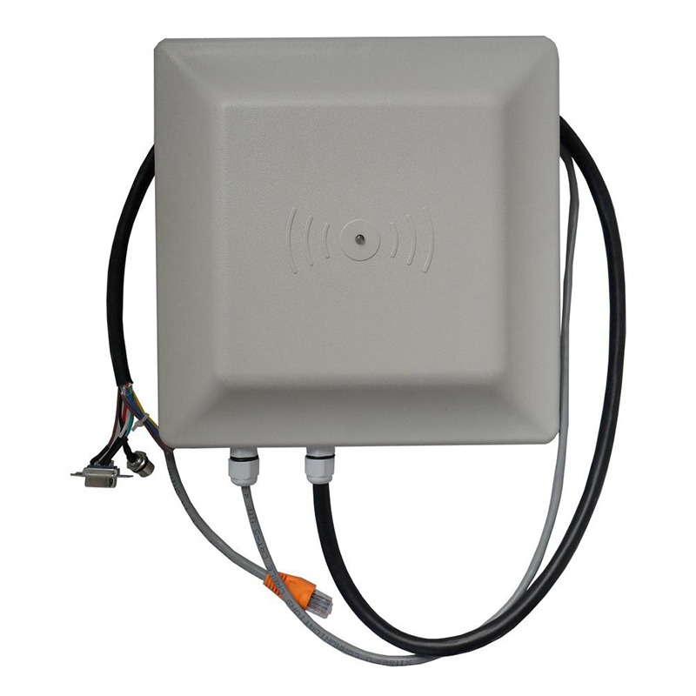
There is an interface at the bottom of RL-R65 reader, connection line shows as follows:
Red | Black | Blue | Yellow | Grey | Purple | orange | palm | darkgreen | white
+12V | Power GND | Wiegand_Data1 | Wiegand_Data0 | Triggering Signal Input | 485+ | 485- | Signal GND | 232Tx | 232Rx
2-1-2
Communication interface in the table of 2-1-2 is of features as follows:
- RS232 Communication interface:
One of RS232 interfaces (DB9jack: RxD receive, Txd send, signal) can be connected directly with PC string mouth.
- Buzzer: inlay buzzer, it sounds whenever reader reads electronic tag.
- Power supply interface: +12V DC outlet (the red one and black one).
- I/O interface
- A RS485 interface (485+ (purple), 485-(orange) signal difference)-for distant signal transmission.
- A wiegand interface: offen use the interface transmission signal in access control system.
Wiegand : use WDATA1-0(yellow),WDATA1-1(blue) 2 lines，
Wiegand interface:
- Signal ground (brown): one GND line for wiegand interface and RS232 interface.
- One trigger signal access,for input:FIN1(grey),low level trigger
When reader in tigger work way, if make down-lead connect with low level trigger, then reader begins to read card numbers till high level is recovered.
  - Performance Index
- Read-write tag:electronic tag in accordance with ISO18000-6B/6C
- Operating frequency: 860～960MHz
- Way of Working:by FHSS or fixed frequency launch
- Output power:0-30dbm(could be a little difference from various countries or area)
- Readdistance:read distance>500cm,write distance>100cm( antenna and tag dependent)
- Read rate:32bits/word,6ms in time,average
- Write rate:32bits/word,50ms in time ,avreage
- Power supply:+12v direct current
- power:<6w ,in average
- Working temperature: -10℃~+55℃
  - Function
- Read tag: electronic tag in accordance with ISO18000-6B,6C
- Can read EPC tags in different length. (16,32,48,64,80 or 96bits)
- Can read EPC Data.
- Can read data from user area.
- Can read data from TID area
- Can read tag’s access and kill password
- Can write different length EPC code (16,32,48,64,80 and 96bits)
- Can write data of user area
- Can revise tag access and kill code
- EPC, TID and user area can be write-protected
- Password section can be write-protected
- Can kill tag
- Device Installation
  - Connection
In system, the connection of reader, antenna, tag and controller (or PC machine) shows as follows:
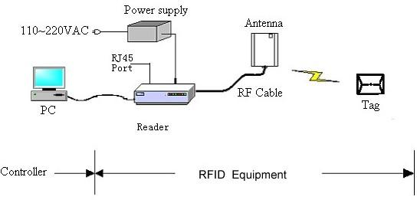
Figure 3-1-1 typical connection about the relevant equipments
  - Connector And Controller
RL-R65 reader can connect with controller through any interface from Weigand, RS485 or RS232
  - Weigand Interface
Under Wiegand port communications, need to connect 3 pins (Data0 (yellow), Data1 (blue), GND (brown)) on reader’s line bank, with the relevant 3 pins on application system control. Reader Wiegand port just sends data unilaterally.
  - RS485 interface
Under RS485 port communications, need to connect 2 pins (RS485+ (purple), RS485-(orange)) on reader’s line bank, with the relevant 2 pins on application system control. Through the converter can also connect with the PC serial port.
  - RS232 interface
RS232 interface can connect with pc directly, by matched cable, length of RS232 interface connection line should be less than 10 meters, drawing shows as 3-2-3
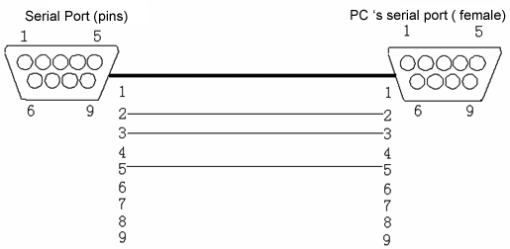 Figure 3-2-2 Reader’s RS232 is connected with PC
  - Connection Power Supply
RL-R65 reader adopts +12V/3A direct current power supply, we can supply you reader with required alternating and current convertor, the way to connect power is as follows:
- Check if voltage of alternating power supply and operating frequency is in accordance with AC 100-240V/50Hz
- Make DC output pin of power convertor insert into +12V direct current power interface of reader.
- Make 220V alternating power input line of convertor insert or connect with line of alternating power supply.
- If the Indicator light of power supply is turn on, that means workable
  - Device Adjustment
Key of device adjustment is: adjust height, direction angle, obiquity, to make reader can read electronic tag in the expected range.Debugging method：
- Turn on reader power supply,set reader to be mode of auto working,close parameter setting procedure ,and disconnect with PC.
- Ture off reader power supply first, and then turn on, reader will automatically turn into state of continuous working.
- As material of identified object and required tag is different,so tag should be stuck to object with same material as identified one,traverses object in the expected range of tag is to read.If reader can get tag,then inlay buzzer tweets and green LED blinks.
- Adjust height and angle of antenna; make reading range at the best.
Note: reader only radiates microwave power when reading tag, then adjuster should keep a distance of 30cm from antenna, that is meet American FCC requirements.
  - Tag Place
In work process of RFID, tag place is a usual job, some notes are as follows:
- Adopts gluewater recommended by factory
- If labeled in the surface of metal, professional glue is recommended.
- Labeled place has to be field tested to make sure read best.
Note: Our Company offers 2 species of tags to customers, in ISO18000-6B standard
- Air medium.can be held to use, also can be instead by our block set, insert card into it directly.
- Glass medium,card should be stuck on glass.(non water-solubility is required)
- Usual Faults
Table 3-1 usual faults and solutions for reader
Fault Phenomena | Possible Reason | Solution
can not read card | antenna is not connected well | Check antenna connection details
can not read card | beyond to reading area of Reader | make card close to module antenna
can not read card | antenna is broken | Change a new antenna
can not read card | Parameter of RF Power is too low | Renew parameter
can not read card | tag is broken | Test in other tag
can not read card | reader is broken | Contact technician
Cannot be connected with reader | no power | Check the power supply connector and adapter
Cannot be connected with reader | Com ties up or broken | Check interface through software and test if it cummunicates
Cannot be connected with reader | baud rate is not set in accordance | Set it to be in accordance by software
Cannot be connected with reader | reader is broken | Contact technician
Reading distance is too near | antenna is not connected well | Check details of antenna connection
Reading distance is too near | Parameter value of RF Power is too low | renew factory parameter
Reading distance is too near | tag is not in accordance with antenna polarization | revolve tag in 90 degree
Reading distance is too near | reader is broken | Contact technician
Reading distance is too near | tag is broken | change a new tag

- After-Sales Service
  - Support And Service
Website please be online with internet by computer; enter http://www.reliablerfid.com to get specifications, purchasing devices and other informations about RL-R65.
Customer support
If you have doubts about instruction and can not get solutions from our website,please contact our customers’ service centre.If your device has to be repaired,please contact us for service information,delivery instruction and maintenance cost excludes from after service before it is sent out.
Service
If device needs to be diagnosed or other service,please contact our customers’ service centre.please don’t send it out before you contact us.If your device is under guarantee,please prepare receipt of purchasing.
Please do as follows before you contact us:
- read introduction
- prepare your machine
  - model
  - serial number
  - receipt of purchasing
- Prepare your machine, customer service representative maybe ask you to operate machine.
- Prepare your questions; detailed problem description can help customer service representative solve your problem at the earliest.
Guarantee
Important information
this text is a guarantee declaration for hardware products, please read carefully.
One year guarantee for hardware
Shenzhen Reliablerfid Technology Co., Ltd offers this hardware product guarantee for no faults in material and manufacture from receipt date of purchasing.
If Shenzhen Reliablerfid Technology Co., Ltd receives fault advise as above during Guarantee date.Shenzhen Reliablerfid Technology Co. Ltd can decide whether to repair or replace the proved failure product.
If Shenzhen Reliablerfid Technology Co., Ltd can not repair or replace the product within reasonable time, customer can ask for refundment.
Scope of warranty
Guarantee above excludes from faults caused as follows:
Misapplication, modification without authorization,open the hardware,operates or stores up this product in an improper environment,damages during transportation,improper maintaince,or caused by not using software ,parts,media,article,expendable from Shenzhen Reliablerfid Technology Co.,Ltd,or project not for this product.
This is the only guarantee declaration for products from Shenzhen Reliablerfid Technology Co., Ltd, noelse guarantee in writing or oral
Shenzhen Reliablerfid Technology will not be responsible for cases as follows: direct, indirect, particular and accidental damage, including profit, whatever it is based on guarantee declaration, agreement, defect, or any other law theory.
Disclaimer clauses: Radio transmission equipment can make interference to the task of any unprotected industry, medical and scientific equipment. There is possible interference to other electronic equipment when this equipment works.If any inquiries in this aspect, please consult from Shenzhen Reliablerfid Technology Co.,Ltd for improvement.
  - Service Hotline
Thank you for choosing our product, we will support you with technology about product application, and offer solutions to any difficulties. Contact mode of our company are as follows:
Company: Shenzhen Reliablerfid Technology Co., Ltd
Address: Room 412, No.1 Building, Ruize jiayuan,Hongmian Road,Henggang,Longgang, Shenzhen, Guangdong, China
Postal code: 518173
Tel: +86 755 28502089
Website: www.reliablerfid.com
Email: info@reliablerfid.com

